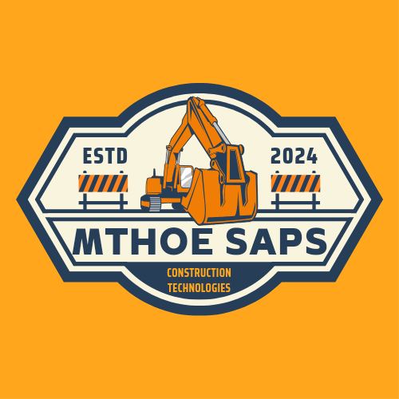

**Mthoe Saps Construction Technologies beta project timelines for implementation**

**Beta project commencement date: 13 May 2024**

**Beta project end date: 13 May 2025**

This is a high level overview of the project timeline of software release dates and how the beta project will run. This should be a go to document for the affiliated parties and the Developer and this document is susceptible to change format and timelines anytime but with clear written consent from the affiliated parties if the Developer needs to push back deadlines or is willing to release new updates ahead of time.

1. The beta project is going to have the following programme:

Development of softwares for beta affiliated companies for geosptial data, GIS and Remote Sensning and well as Property Management softwares.

The software package is as follows:

Companies that sign up for the Mthoe Saps Construction Technologies Bulawayo Mapping Survey Engine beta project will get the following softwares:

(i) Access to a Private web app by Mthoe Saps Construction Technologies

(ii) Geographic Information Systems (GIS) and Remote Sensing Mapping and Surveying software from Mthoe Saps Construction Technologies

(iii) A Property Management Systems Software that manages properties and real estate

(iv) A Real Time Property Surveillance Software to view properties in real time

(v) Three free 3D drone Mapping and Survey projects each

2. Software package delivery dates:

(i) Access to a Private web app by Mthoe Saps Construction Technologies - Upon commencement of beta project 13 May 2024 companies will be given first hand access to the most well optimized and designed engine model that we are working on as the final product of out beta project.

(ii) Geographic Information Systems (GIS) and Remote Sensing Mapping and Surveying software from Mthoe Saps Construction Technologies - 13-16 May 2024 beta affiliated organizations will get their first Mapping softwares that have full GIS and Remote sensing abilities.

(iii) A Property Management Systems Software that manages properties and real estate - 09 September 2024 - beta affiliated companies will gain their own property management software/ web app that will be used to map, locate and display properties on the site.

(iv) A Real Time Property Surveillance Software to view properties in real time - 16 December 2024 - beta affiliated companies will gain their own property surveillnce system that has cameras and high level object recognition algorithms.

(v) Three free 3D drone Mapping and Survey projects each - start from 7 January 2025 - each beta affiliated company will get a free 3D drone survey of their choice, this survey could be claimed anytime as its a once off free survey and it can even be claimed years after the beta project has passed.

NB: Note that these dates are just estimates of how the beta project will run, realistic goals have to be met thus these dates are susceptible to change depending on the working conditions and resources available at the time.

In total, beta affiliated companies will get 3 softwares of their own, access to the original beta project and all the technological advancements made and they will also get to have one free 3D drone survey of their choice.

3. Milestones to accomplish:

Handing out of beta project forms to potential affilate companies: 25 April - 13 May 2024

Add all beta project members to original project: 13 May - 16 May

Simulating drone flights and optimization of software for drone mapping: 25 April 2024 - 03 January 2025

Distribution of GIS and Remote sensing software to affiliated parties: 16 May - 19 May 2024

Develop a fully optimized Property Management software and Property Surveillance softwwares : 19 May - 03 September 2024

Fully optimize and integrate all affiliated partners apps into one super survey engine: 08 September to 12 December 2024

Release a super survey engine web app for each affiliated party: 16 December 2024

4. Dependencies and Constraints:

Please note that some unforseen factors might hinder the progress of the beta project and have timeline overlaps on some research aspects/areas. These dependencies and constraints have all been thorougly thought of and analyzed and mitigation strategies have since been developed to ensure that this beta project runs smoothly and that there is a transparent, respectful, trustworthy and professional line of communication and conduct between the affiliated beta organizations and the Developer.

5. Assumptions and risks:

The main assumption and risk that we have is that we might have a challenge only with meeting deadlines and software programming needs detailed planning and paying close attention to detail this the only constraint we might be looking to deal with is time but our mitigation strategty is quite simple and effective as it is to develop updates and new software features regularly in the background. As it is we have scheduled drone mapping and surveying to commence on 7 January 2025 but we have already developed our autonomous drone simulation scripts/codes and flight plans meaning we are already way ahead of the development timeline. Just for our affiliated parties benefits, we have already made prototype softwares for the upcoming software updates and releases thus we are confident that we will finish this beta project in one smooth flow.

6. Communication and Reporting:

Mthoe Saps Construction Technologies will make a secondary website that will for posting project updates, an it will have text input forms and a contact me page, you can use any of those functions to get in contact with me.

7. Conclusion:

In summary the project has these cabilities:

1. Able to convert excel, csv, json files (any type of dataset or database) in to visually and graphically interpretable charts, graphs and maps.

2. Able to send drones on autonomous missions (simulated flights).

3. Able to perfom 3D drone land surveys.

4. Able to analyze, manipulate and interpret alot of data patterns.

5. Able to create our own realtime mapping systems and databases on the ground here in Bulawayo instead of depending on international software firms